Product name: Medic 2 – First Aid Kit – B.T.P. 10 to 20 Persons
Cod: FRK024
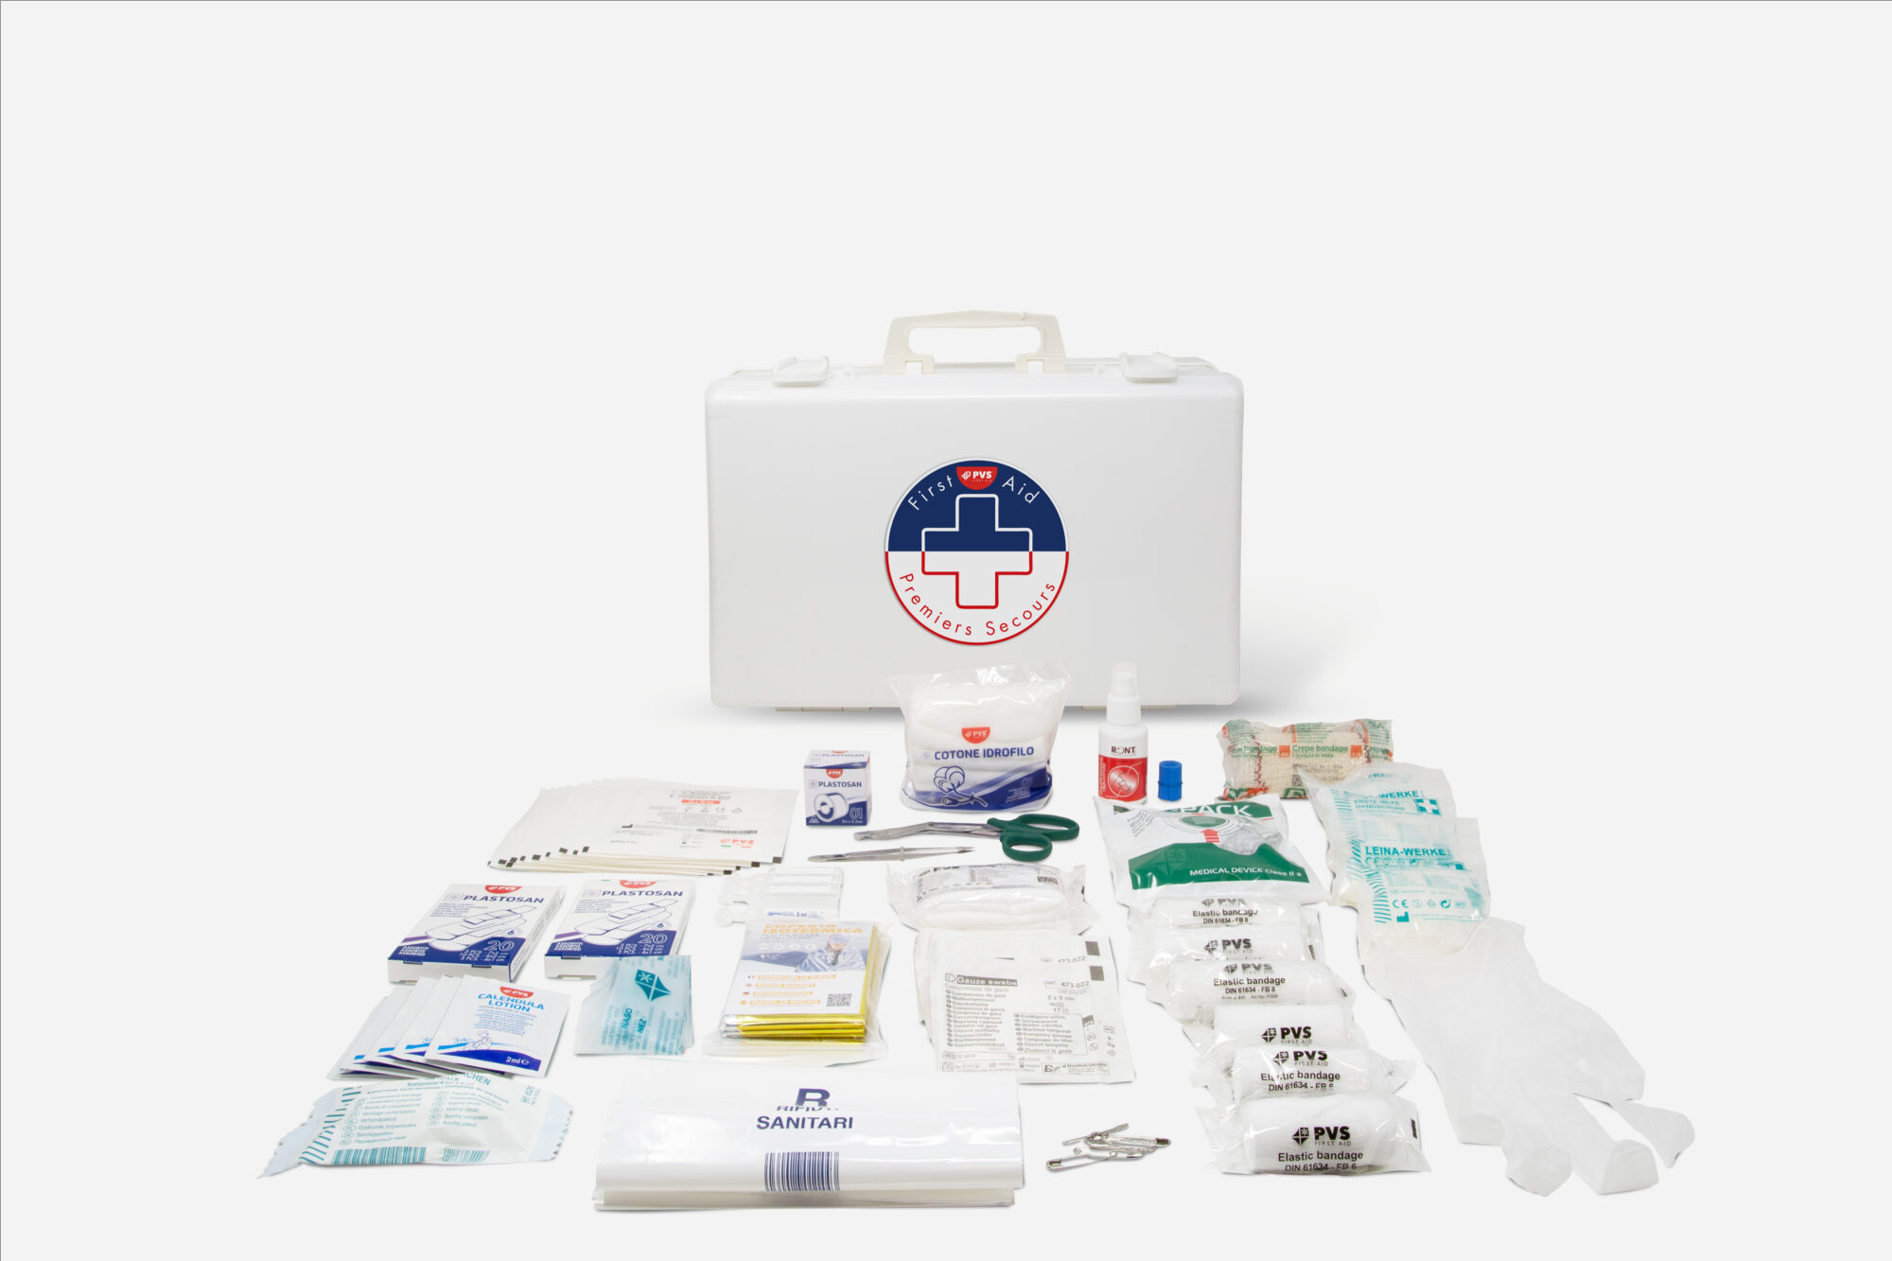
Regulations: The products defined as medical devices are compliant with MDR 745/2017 of 05/04/2017

Italiano | Descrizione: Valigetta di primo soccorso per il settore B.T.P., indicata per gruppi da 10 a 20 persone. Struttura in plastica antiurto con scomparti interni per organizzazione rapida.  Istruzioni: Aprire la valigetta e verificare l’integrità dei dispositivi. Usare i presidi seguendo le corrette procedure di primo soccorso (medicazione, protezione, immobilizzazione, rianimazione di base). Dopo l’uso smaltire i materiali monouso secondo normativa locale, sanificare le superfici e reintegrare i componenti mancanti. Conservare in luogo asciutto e pulito, al riparo da calore e agenti corrosivi.  Contenuto del kit:  1 × Tampobenda 60 × 80 cm sterile (DIN 13151-K)  1 × Coperta isotermica oro/argento 160 × 210 cm  2 × Sacchetti rifiuti sanitari 180 × 250 mm, minigrip  1 × VENTO rianimatore bocca-a-bocca, 4 lingue  2 × Astuccio 20 cerotti assortiti  5 × Garza idrofila sterile 20 × 20 cm (5 × 5)  10 × Compresse di garza sterili 10 × 10 cm, 8 strati  3 × Benda elastica 4 m × 6 cm (DIN 61634)  3 × Benda elastica 4 m × 8 cm (DIN 61634)  1 × Benda di crépe 4 m × 10 cm  1 × Rocchetto cerotto TNT 5 m × 2,5 cm  1 × Telo triangolare TNT 96 × 96 × 136 cm  1 × Spray clorexidina 50 ml  5 × Salviette alla calendula  1 × Forbici Lister 14,5 cm (DIN)  1 × Pinzetta sterile 10 cm  1 × Confezione 6 spille 38 mm  3 × Paio di guanti copolimero sterili, misura unica  1 × Manuale in francese/spagnolo/portoghese  1 × Laccio piatto emostatico in nitrile 46 × 2,5 cm  1 × Cotone idrofilo, confezione 20 g  1 × Ghiaccio istantaneo (ICE PACK)  5 × BURNSHIELD gel per ustioni sterile 3,5 g
English | Description: First-aid case for the B.T.P. sector, suitable for groups of 10 to 20 persons. Shock-resistant plastic case with internal compartments for quick access.  Instructions: Open the case and check that devices are intact. Use items according to correct first-aid procedures (wound care, protection, immobilization, basic resuscitation). After use, dispose of single-use materials per local regulations, sanitize surfaces and replenish missing components. Store in a clean, dry place away from heat and corrosive agents.  Kit contents:  • 1 × Sterile dressing pad 60 × 80 cm (DIN 13151-K)  • 1 × Thermal blanket gold/silver 160 × 210 cm  • 2 × Medical waste bags 180 × 250 mm, minigrip  • 1 × VENTO one-way CPR shield (mouth-to-mouth), 4 languages  • 2 × Boxes of 20 assorted plasters  • 5 × Sterile hydrophilic gauze 20 × 20 cm (5 × 5)  • 10 × Sterile gauze compresses 10 × 10 cm, 8-ply  • 3 × Elastic bandage 4 m × 6 cm (DIN 61634)  • 3 × Elastic bandage 4 m × 8 cm (DIN 61634)  • 1 × Crepe bandage 4 m × 10 cm  • 1 × Non-woven adhesive tape roll 5 m × 2.5 cm (TNT)  • 1 × Triangular sling (TNT) 96 × 96 × 136 cm  • 1 × Chlorhexidine spray 50 ml  • 5 × Calendula wipes  • 1 × Lister scissors 14.5 cm (DIN)  • 1 × Sterile tweezers 10 cm  • 1 × Set of 6 safety pins, 38 mm  • 3 × Pairs of sterile copolymer gloves, one size  • 1 × Manual (FR/ES/PT)  • 1 × Flat tourniquet in nitrile 46 × 2.5 cm  • 1 × Absorbent cotton, 20 g bag  • 1 × Instant ice pack (ICE PACK)  • 5 × BURNSHIELD sterile burn gel 3.5 g
French | Description: Mallette de premiers secours pour le secteur B.T.P., adaptée aux groupes de 10 à 20 personnes. Boîtier plastique antichoc avec compartiments internes pour un accès rapide.  Mode d’emploi: Ouvrir la mallette et vérifier l’intégrité des dispositifs. Utiliser les articles selon les bonnes procédures de premiers secours (soins des plaies, protection, immobilisation, réanimation de base). Après usage, éliminer les matériaux à usage unique selon la réglementation locale, désinfecter les surfaces et réapprovisionner les composants manquants. Conserver dans un endroit propre et sec, à l’abri de la chaleur et des agents corrosifs.  Contenu du kit:  • 1 × Sterile dressing pad 60 × 80 cm (DIN 13151-K)  • 1 × Thermal blanket gold/silver 160 × 210 cm  • 2 × Medical waste bags 180 × 250 mm, minigrip  • 1 × VENTO one-way CPR shield (mouth-to-mouth), 4 languages  • 2 × Boxes of 20 assorted plasters  • 5 × Sterile hydrophilic gauze 20 × 20 cm (5 × 5)  • 10 × Sterile gauze compresses 10 × 10 cm, 8-ply  • 3 × Elastic bandage 4 m × 6 cm (DIN 61634)  • 3 × Elastic bandage 4 m × 8 cm (DIN 61634)  • 1 × Crepe bandage 4 m × 10 cm  • 1 × Non-woven adhesive tape roll 5 m × 2.5 cm (TNT)  • 1 × Triangular sling (TNT) 96 × 96 × 136 cm  • 1 × Chlorhexidine spray 50 ml  • 5 × Calendula wipes  • 1 × Lister scissors 14.5 cm (DIN)  • 1 × Sterile tweezers 10 cm  • 1 × Set of 6 safety pins, 38 mm  • 3 × Pairs of sterile copolymer gloves, one size  • 1 × Manual (FR/ES/PT)  • 1 × Flat tourniquet in nitrile 46 × 2.5 cm  • 1 × Absorbent cotton, 20 g bag  • 1 × Instant ice pack (ICE PACK)  • 5 × BURNSHIELD sterile burn gel 3.5 g
German | Beschreibung: Erste-Hilfe-Koffer für den B.T.P.-Bereich, geeignet für Gruppen von 10 bis 20 Personen. Schlagfester Kunststoffkoffer mit Innenfächern für schnellen Zugriff.  Anleitung: Koffer öffnen und Unversehrtheit der Komponenten prüfen. Hilfsmittel gemäß korrekten Erste-Hilfe-Verfahren verwenden (Wundversorgung, Schutz, Immobilisierung, Basis-Reanimation). Nach Gebrauch Einwegmaterial gemäß lokalen Vorschriften entsorgen, Oberflächen desinfizieren und fehlende Komponenten nachfüllen. Kühl, trocken und fern von Hitze sowie korrosiven Stoffen lagern.  Lieferumfang:  • 1 × Steriles Verbandkissen 60 × 80 cm (DIN 13151-K)  • 1 × Rettungsdecke gold/silber 160 × 210 cm  • 2 × Beutel für medizinische Abfälle 180 × 250 mm, Minigrip  • 1 × VENTO Einweg-Beatmungstuch (Mund-zu-Mund), 4 Sprachen  • 2 × Schachteln mit 20 gemischten Pflastern  • 5 × Sterile hydrophile Gaze 20 × 20 cm (5 × 5)  • 10 × Sterile Mullkompressen 10 × 10 cm, 8-lagig  • 3 × Elastische Binde 4 m × 6 cm (DIN 61634)  • 3 × Elastische Binde 4 m × 8 cm (DIN 61634)  • 1 × Kreppbinde 4 m × 10 cm  • 1 × Vlies-Heftpflasterrolle 5 m × 2,5 cm (TNT)  • 1 × Dreiecktuch aus Vlies 96 × 96 × 136 cm  • 1 × Chlorhexidin-Spray 50 ml  • 5 × Ringelblumen-Tücher  • 1 × Lister-Schere 14,5 cm (DIN)  • 1 × Sterile Pinzette 10 cm  • 1 × Set mit 6 Sicherheitsnadeln, 38 mm  • 3 × Paar sterile Copolymer-Handschuhe, Einheitsgröße  • 1 × Handbuch (FR/ES/PT)  • 1 × Flacher Stauschlauch aus Nitril 46 × 2,5 cm  • 1 × Verbandwatte, Beutel 20 g  • 1 × Sofort-Kältebeutel (ICE PACK)  • 5 × BURNSHIELD Brandgel steril 3,5 g
Spanish | Descripción: Maletín de primeros auxilios para el sector B.T.P., indicado para grupos de 10 a 20 personas. Estuche de plástico resistente a impactos con compartimentos internos para acceso rápido.  Instrucciones: Abra el maletín y compruebe la integridad de los dispositivos. Utilice los elementos según los procedimientos correctos de primeros auxilios (curas, protección, inmovilización, reanimación básica). Tras el uso, deseche los materiales de un solo uso de acuerdo con la normativa local, desinfecte las superficies y reponga los componentes faltantes. Conservar en un lugar limpio y seco, protegido del calor y de agentes corrosivos.  Contenido del kit:  • 1 × Compresa de vendaje estéril 60 × 80 cm (DIN 13151-K)  • 1 × Manta isotérmica oro/plata 160 × 210 cm  • 2 × Bolsas de residuos sanitarios 180 × 250 mm, minigrip  • 1 × Barrera de RCP VENTO unidireccional (boca a boca), 4 idiomas  • 2 × Cajas con 20 tiritas surtidas  • 5 × Gasa hidrófila estéril 20 × 20 cm (5 × 5)  • 10 × Compresas de gasa estériles 10 × 10 cm, 8 capas  • 3 × Venda elástica 4 m × 6 cm (DIN 61634)  • 3 × Venda elástica 4 m × 8 cm (DIN 61634)  • 1 × Venda de crepé 4 m × 10 cm  • 1 × Rollo de esparadrapo no tejido 5 m × 2,5 cm (TNT)  • 1 × Triángulo de tela TNT 96 × 96 × 136 cm  • 1 × Spray de clorhexidina 50 ml  • 5 × Toallitas de caléndula  • 1 × Tijeras Lister 14,5 cm (DIN)  • 1 × Pinza estéril 10 cm  • 1 × Pack de 6 imperdibles 38 mm  • 3 × Pares de guantes estériles de copolímero, talla única  • 1 × Manual (FR/ES/PT)  • 1 × Torniquete plano de nitrilo 46 × 2,5 cm  • 1 × Algodón hidrófilo, bolsa 20 g  • 1 × Hielo instantáneo (ICE PACK)  • 5 × Gel para quemaduras BURNSHIELD estéril 3,5 g

PVS SpA – Cassina de Pecchi IT - Rev. - 11/11/2025

